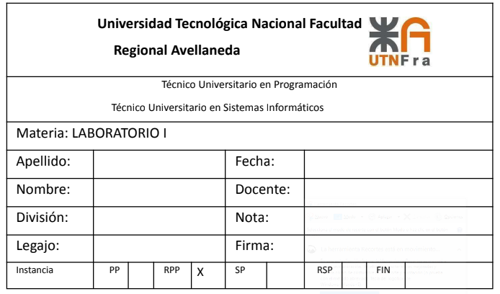

Nahuel

1B

Scarafilo, Luchetta, Taboada, Fernandez

17/6/2022

Gimenez

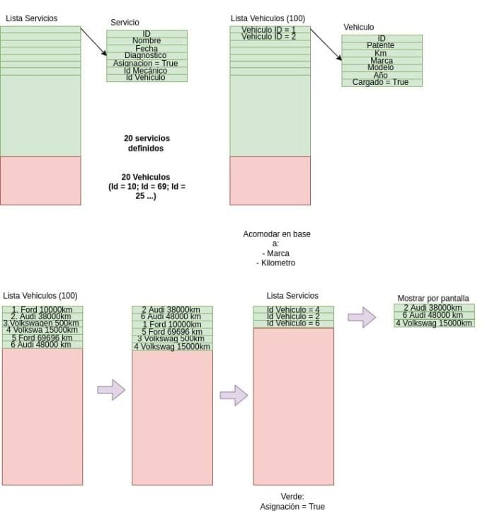

Link al video de la defensa: https://drive.google.com/file/d/1-HHqg_nBvMQwHpJg4s7JMmmyocmaBP0m/view?usp=sharing